Case Study Report



**Tech Saksham**

Data Analytics with Power BI

**“360-Degree Business Analysis of Online Delivery Apps”**

**“K.R. College of Arts & Science”**

|  |  |
| --- | --- |
| **NM ID** | **NAME** |
| 9C51C44B40B21408B0E42BE709010808 | MUKESH M |

|  |  |
| --- | --- |
|  |  |
|  | Trainer Name : R UMAMAHESWARI |
|  | Master Trainer : R UMAMAHESWARI |

**ABSTRACT**

This abstract might summarize a report comparing the performance and features of different online delivery apps, utilizing data analytics to benchmark against industry standards and identify areas of competitive advantage or improvement.

**INDEX**

|  |  |  |
| --- | --- | --- |
| **Sr. No.** | **Table of Contents** | **Page No.** |
| 1 | Chapter 1: Introduction | 4 |
| 2 | Chapter 2: Services and Tools Required | 6 |
| 3 | Chapter 3: Project Architecture | 7 |
| 4 | Chapter 4: Modeling and Result | 9 |
| 5 | Conclusion | 18 |
| 6 | Future Scope | 19 |
| 7 | References | 20 |
| 8 | Links | 21 |

**CHAPTER 1**

**INTRODUCTION**

* 1. **Problem Statement**

Focusing on the optimization of menu offerings and inventory management for online delivery apps, this problem statement might highlight the need to leverage data analytics to analyze sales trends, manage inventory levels efficiently, and minimize waste.

* 1. **Proposed Solution**

Developing a robust fraud detection system using data analytics can enhance the security of online delivery apps. By analyzing transaction data, user behavior, and historical patterns, the app can detect and prevent fraudulent activities, safeguarding user information and financial transactions.

* 1. **Feature**
* **Real-Time Analysis**: The dashboard will provide real-time analysis of restaurants in data.
* **Customer Segmentation**: It will segment Restaurants based on various parameters.
* **Trend Analysis**: The dashboard will identify and display trends in restaurant behavior.
* **Predictive Analysis**: It will use historical data to predict future restaurant behavior.
  1. **Advantages**
* **Data-Driven Decisions**: Online Delivery Apps can make informed decisions based on real-time data analysis.
* **Improved Customer Engagement**: Understanding customer behavior and trends can help Online Delivery Apps engage with their customers more effectively.
* **Increased Revenue**: By identifying opportunities for cross-selling and up-selling, Online Delivery Apps can increase their revenue.
  1. **Scope**

This scope focuses on mitigating risks and enhancing security within online delivery apps through data analytics. It involves developing fraud detection systems, analyzing transaction data for anomalies, and implementing measures to safeguard user information and financial transactions.

**CHAPTER 2**

**SERVICES AND TOOLS REQUIRED**

**2.1 Services Used**

* **Data Collection and Storage Services**: Banks need to collect and store customer data in real-time. This could be achieved through services like Azure Data Factory, Azure Event Hubs, or AWS Kinesis for real-time data collection, and Azure SQL Database or AWS RDS for data storage.
* **Data Processing Services**: Services like Azure Stream Analytics or AWS Kinesis Data Analytics can be used to process the real-time data.
* **Machine Learning Services**: Azure Machine Learning or AWS SageMaker can be used to build predictive models based on historical data.

**2.2 Tools and Software used**

**Tools**:

* **PowerBI**: The main tool for this project is PowerBI, which will be used to create interactive dashboards for real-time data visualization.
* **Power Query**: This is a data connection technology that enables you to discover, connect, combine, and refine data across a wide variety of sources.

**Software Requirements**:

* **PowerBI Desktop**: This is a Windows application that you can use to create reports and publish them to PowerBI.
* **PowerBI Service**: This is an online SaaS (Software as a Service) service that you use to publish reports, create new dashboards, and share insights.
* **PowerBI Mobile**: This is a mobile application that you can use to access your reports and dashboards on the go.

**CHAPTER 3**

**PROJECT ARCHITECTURE**

**3.1 Architecture**

**USER FRONTEND BACKEND**

|  |  |  |
| --- | --- | --- |
|  | **HTML 5** | **NODEJS 14.0**  **Database** |

Here’s a high-level architecture for the project:

1. **Data Collection**: Real-time customer data is collected from various sources like bank transactions, customer interactions, etc. This could be achieved using services like Azure Event Hubs or AWS Kinesis.
2. **Data Storage**: The collected data is stored in a database for processing. Azure SQL Database or AWS RDS can be used for this purpose.
3. **Data Processing**: The stored data is processed in real-time using services like Azure Stream Analytics or AWS Kinesis Data Analytics.
4. **Machine Learning**: Predictive models are built based on processed data using Azure Machine Learning or AWS SageMaker. These models can help in predicting customer behavior, detecting fraud, etc.
5. **Data Visualization**: The processed data and the results from the predictive models are visualized in real-time using PowerBI. PowerBI allows you to create interactive dashboards that can provide valuable insights into the data.
6. **Data Access**: The dashboards created in PowerBI can be accessed through PowerBI Desktop, PowerBI Service (online), and PowerBI Mobile.

**CHAPTER 4**

**MODELING AND RESULT**

**Manage relationship**

The “KPI’s” file will be used as the main connector as it contains most key identifier which can be use to relates the 8 data files together. The “district” file is use to link the client profile geographically with “Country Code”

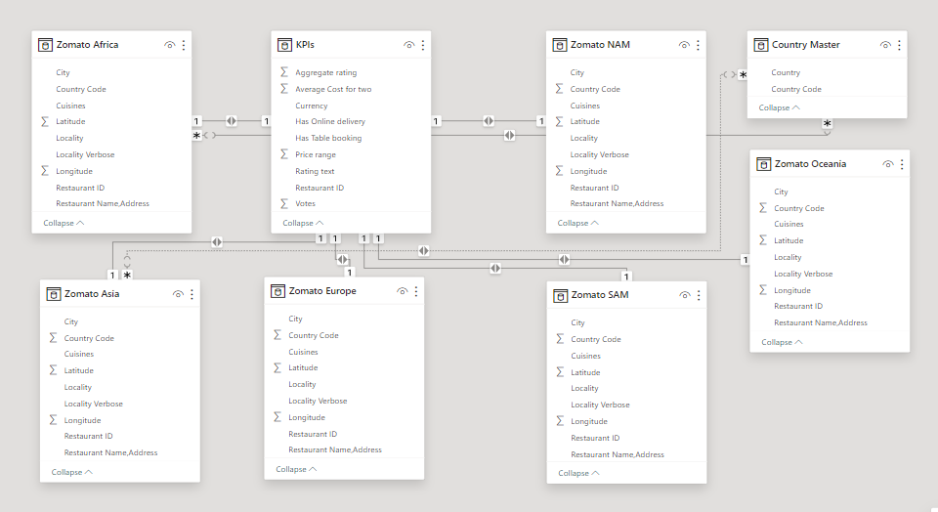

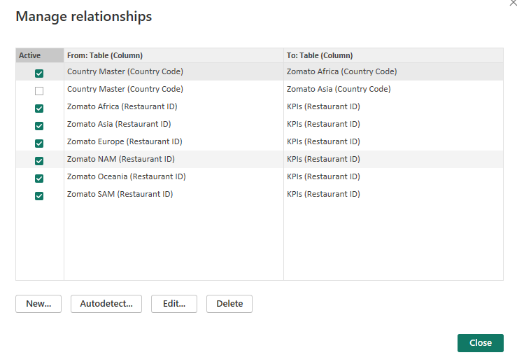

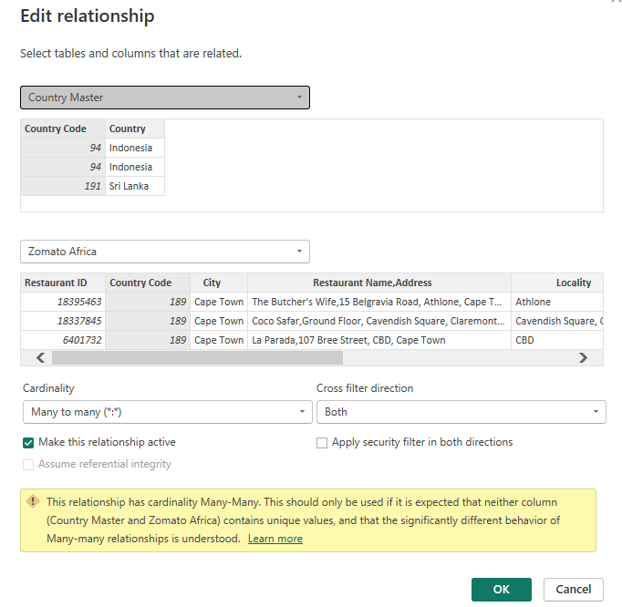

**Replacing values**

Set some fields to English for easy understanding, we replace values to English with the Power Query Editor.

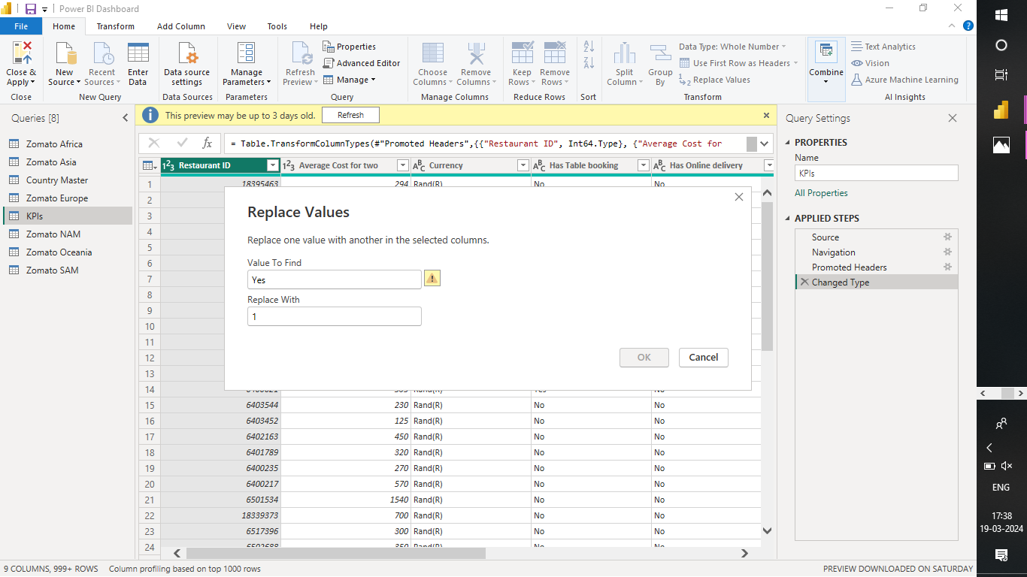

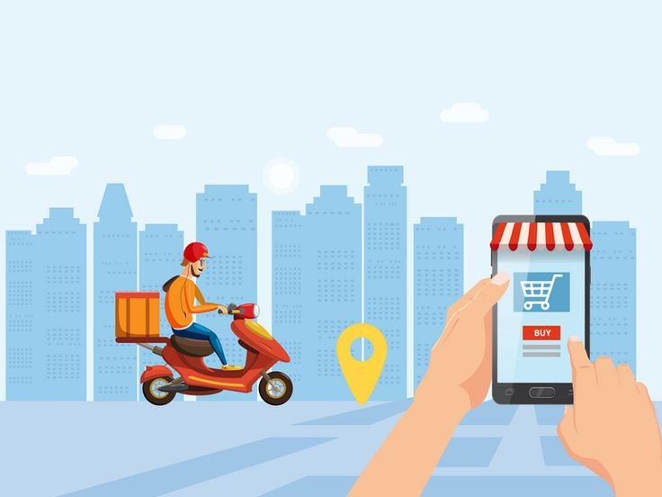 **OBJECTIVE :**

Assess customer feedback, ratings, reviews to gauge

overall satisfaction levels and pinpoint areas needing attention.

**Dashboard**

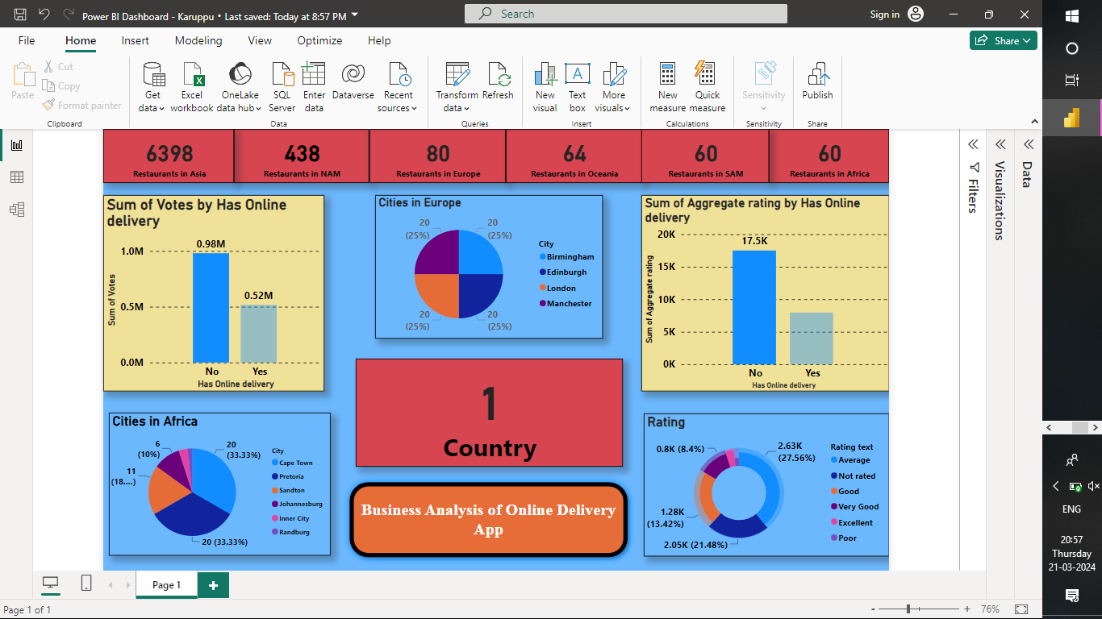

**CONCLUSION**

The conclusion may discuss the broader implications of the data analysis findings on industry trends within the online delivery app sector. This could involve insights into how the findings contribute to shaping industry practices, consumer behavior, or technological advancements.Top of Form

**FUTURE SCOPE**

This context focuses on addressing ethical considerations and data privacy concerns associated with the use of data analytics in online delivery apps. Future scope could involve developing transparent data policies, implementing robust security measures, and ensuring compliance with data protection regulations to build trust with users.

**REFERENCES**

<https://medium.com/analytics-vidhya/analysis-of-bank-customers-using-dashboard-in-power-bi-a366f2b3e563>

**LINK**

<https://github.com/githubtraining/hellogitworld.git>